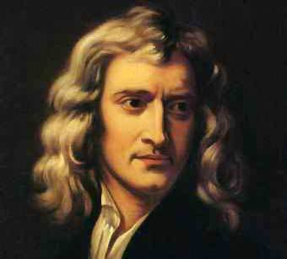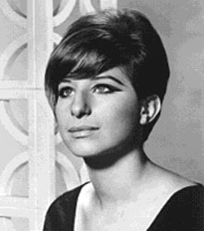

**The Effects of Stress: The Psychiatric Element**

Naomi Campbell

Heath Ledger

Barbara Streisand

Isaac Newton

Barbara Streisand

What do these celebrities all have in common? (...Apart from being celebrities of course)

...

That’s right! They have all suffered from varying degrees of stress.

**Stress and Depression**

Brown and Harris (1978)  
- Found that women who suffered chronic stress conditions (i.e. having more than three children under the age of 14 at home, being unemployed etc) were more likely to develop depression.

-Also reported w/c women were more prone to depression than m/c women due to the stress of having to leave home to work and leaving their children in the care of others.

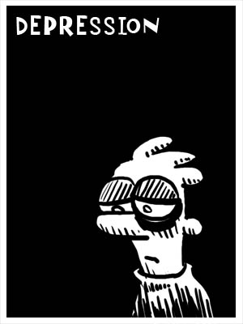

Melchior *et al* (2007)  
- Carried out survey over a period of a year among 1000 32 year olds in wide range of occupations in New Zealand  
- Found that 15% of those in high stress jobs suffered from clinical depression, compared to the 8% in low-stress jobs

**Stress and other disorders**

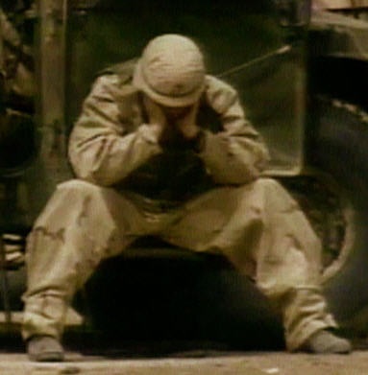

The end of the Vietnam war in 1975 distinguished the existence of Post Traumatic Stress Disorder. PTSD has been observed in war veterans and rape victims, as well as victims of chronic stressors such as poverty and abuse.

Perpetration Induced Traumatic Stress (MacNair 2002) is a form of PTSD caused by being an active participant in *causing* trauma (i.e. police officers, executioners

Rohlf and Bennett (2005) 1/10 workers whose occupation required euthanising animals, experienced moderate levels of PITS syndrome. 



In order for a person to develop a psychiatric disorder, they must possess a biological vulnerability to that disorder (the diathesis). An individual’s vulnerability is determined by genetic or early biological factors (such as exposure to viral infection when in the womb).

Stress can have an impact on that vulnerability, either by triggering the disorder or worsening the condition. If the person is vulnerable, that is they are not capable of adapting to the situation, the psychiatric symptons will develop or *worsen*.

**The diathesis-stress model**