Stress and life changes
Two medical doctors, Holmes and Rahe (1967) played a key role in developing the idea that life changes are linked to stress and illness. In the course of treating patients, they observed that it was often the case that a range of major life events seemed to precede physical illness. These changes were both positive and negative events that had one thing in common- they involved change. Change requires psychic energy to be expended i.e. it is stressful. Holmes and Rahe suggested that this affected health.
Using life changes to measure stress
Holmes and Rahe (1967) developed the Social Readjustment Rating Scale (SRRS) based on 43 life events taken from their analysis of over 5000 patient records.
- About 400 participants
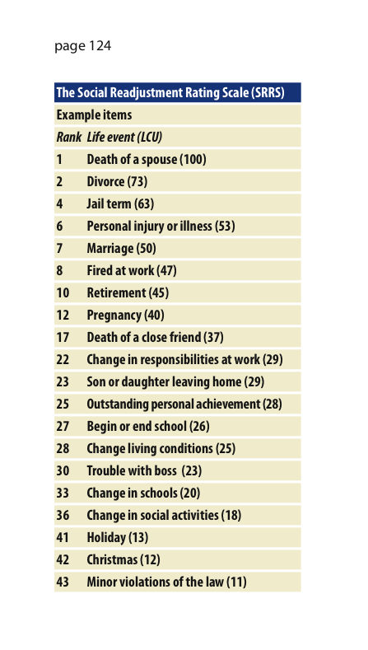
- PPs were asked to score each event in terms of how much readjustment would be required by the average person
- PPs would be asked to provide a numerical figure for this readjustment (e.g. taking marriage as an arbitrary baseline value of 50)
- If an event would take longer to readjust than marriage, then they were told to give the event an even larger score.
- Scores for all participants were totalled and averaged to produce life change units (LCUs) for each life event (shown in the table on the right).

Strengths and weaknesses
- Research using the SRRS appears to suggest that any life-changing event has the potential to damage health because of the significant readjustment it entails.
- Some critics now suggest that it is the quality of the event that is crucial, with ‘undesired, unscheduled and uncontrolled’ changes being the most harmful.

