Group 4
Stress and life changes/ daily hassles
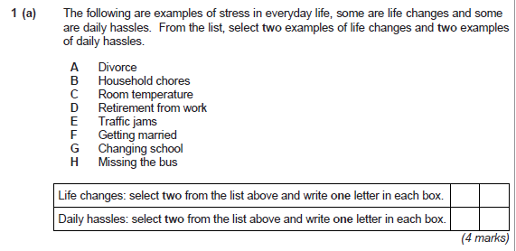
Answer:
- Life changes : A, D, F, G
- Daily hassles : B, C, E, H
“Psychological research has provided evidence to support the view that stress can be caused by life changes. It has also provided evidence of individual differences in response to sources of stress.”
Discuss the view that stress is environmentally determined. (12 marks)

